Imizamo Yethu Aftercare – User Guide

Imizamo Yethu Aftercare Management System by NovaTech Solutions
Client: Imizamo Yethu Learning Hub (Aftercare)
Module: INSY7315 Work Integrated Learning

Prepared by NovaTech Solutions:
Team member | Student number
Michaela Ferraris | ST10325652
Isabelle Kathryn Devlin | ST10445500
Thomas Pheiffer | ST10068995
Nomsa Mkoka | ST10301146
Justin Fussell | ST10280758

Live application: imizamo-yethu-aftercare-webapp (Azure)

1. Introduction
The Imizamo Yethu Aftercare system replaces paper registers with one web app for daily attendance, safe collection at home time, learner development notes and donor reports. It runs in any modern browser on a phone, tablet or computer, so there is nothing to install.
This guide gives step-by-step instructions for each of the four kinds of user. Read section 2 first, then go to the section for your role:
You are… | You use the app to… | Go to
Teacher | Take the register, sign learners out, record observations | Section 3
Manager | Run the centre: learners, classes, staff, parents, reports | Section 4
Parent or guardian | See your child's day, attendance and progress; add pickup people | Section 5
Admin (standard or master) | View reports; the master admin also manages staff accounts | Section 6

The system protects children's information under POPIA. Each person only sees what their role needs: parents see only their own children, and pickup lists never show phone numbers to staff screens.

2. Getting started
2.1 What you need
Requirement | Minimum
Device | Any smartphone, tablet, laptop or desktop computer
Browser | A current version of Chrome, Edge, Safari or Firefox (released in the last two years)
Internet | Any working connection, including mobile data
Screen | Works from 375 px wide (small phones) up to large desktop screens
Account | Staff: an email and password from the master admin. Parents: register yourself (2.3)

Nothing needs to be installed. On a phone you can add the site to your home screen from the browser's share or menu button, so it opens like an app.
Screen layout. On a phone, the main pages are buttons in a bar at the bottom of the screen. On a tablet or computer, the same buttons sit in a sidebar on the left. Your name and role show at the top left, and the settings button (⚙️) sits at the top right.
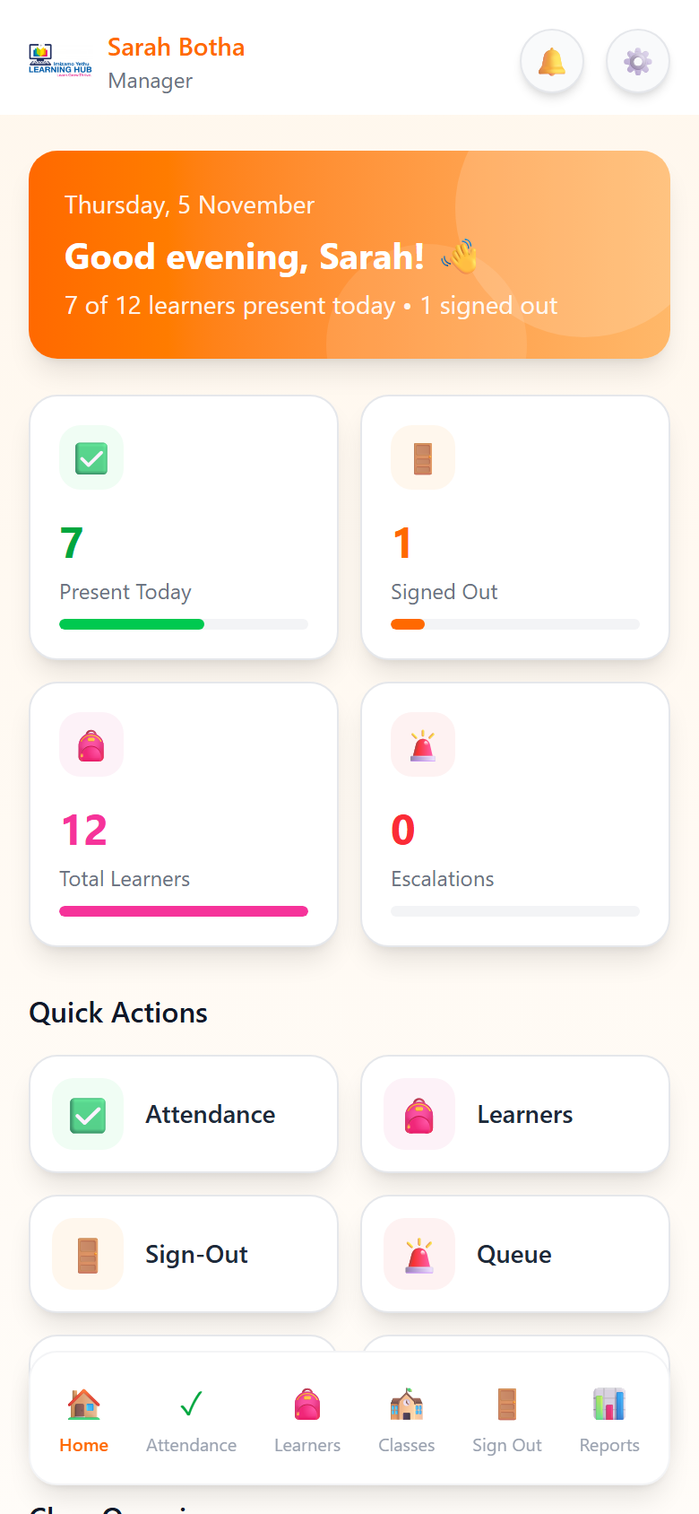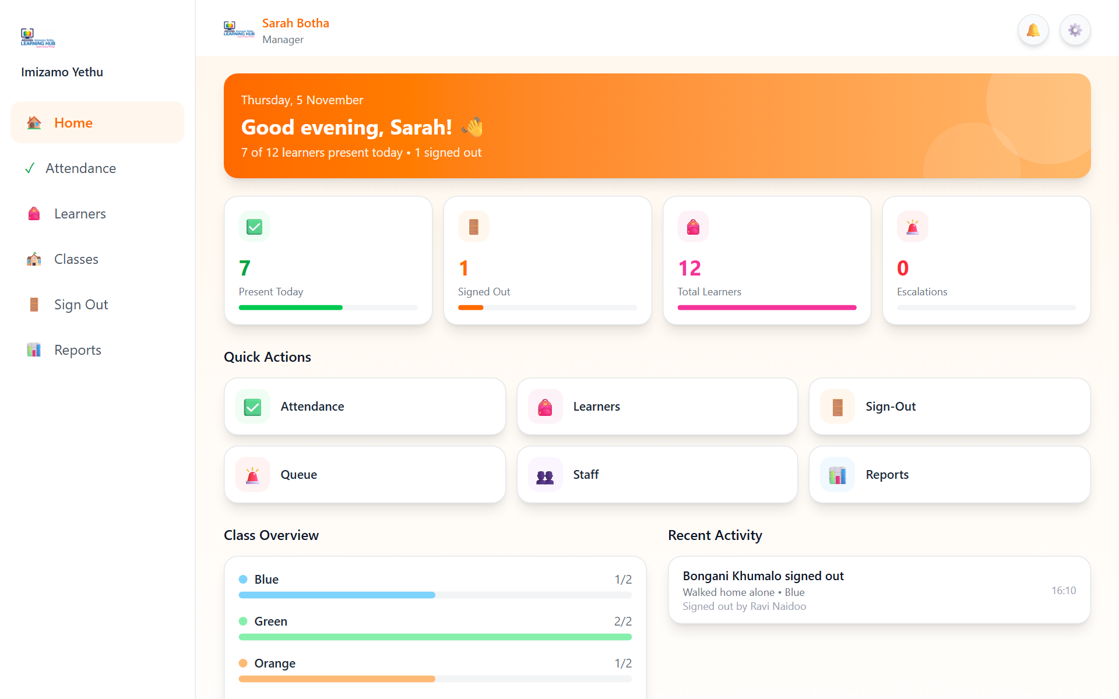
Figure 1: the same page on a phone (bottom bar) and on a computer (sidebar), with the navigation and settings button circled

2.2 Signing in
- Open the live application in your browser.
- Under Sign in as, tap your role card: Teacher, Manager, Admin or Parent/Guardian. The chosen card is outlined in orange.
- Type your Email and Password.
- Tap Sign In. You go straight to the home page for your role.
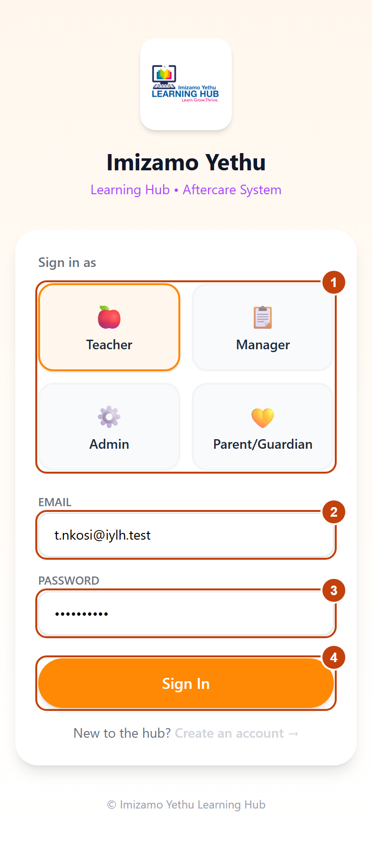
Figure 2: Login screen – (1) role cards, (2) email, (3) password, (4) Sign In button
Good to know:
- The role card must match your account. A teacher who picks Manager sees "Wrong account type for the role selected". Pick the right card and try again.
- The master admin picks the Admin card and lands on the manager pages, because a master admin can do everything a manager can.
- You stay signed in for up to 8 hours, even if you refresh the page.
2.3 Registering as a parent or guardian
Only parents and guardians create their own accounts. Staff accounts are created for them (section 6.2).
- On the login screen, tap the Parent/Guardian card, then Create an account →.
- Fill in every field: first name, last name, email address, phone number and your relationship to the child (for example Mother, Grandmother, Legal guardian).
- Type your child's full name and date of birth exactly as the centre has them. This is how the app links your account to your child.
- Choose a password of at least 8 characters and type it again to confirm.
- Tap Create Account. You return to the login screen with "Account created. Please sign in."
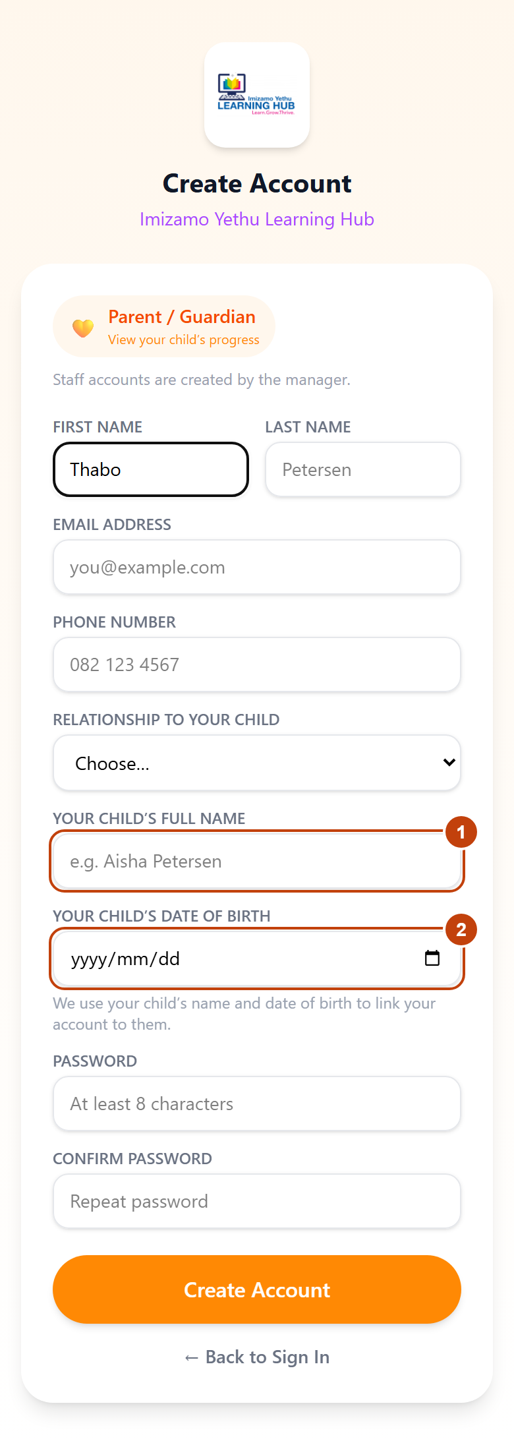
Figure 3: Create Account form with the child's name and date of birth fields highlighted
If you see "We couldn't find a learner with that name and date of birth", check the spelling and the date, or ask the centre how your child is listed. Tapping Create an account with a staff card selected explains that staff accounts are made by the master admin.
2.4 Changing your password
- Open Settings: teachers and parents tap ⚙️ at the top right; managers and admins tap ⋮, then Settings.
- Under Change password, type your current password, then the new one twice (at least 8 characters, different from the current one).
- Tap Update password. You stay signed in here and are signed out on any other device.
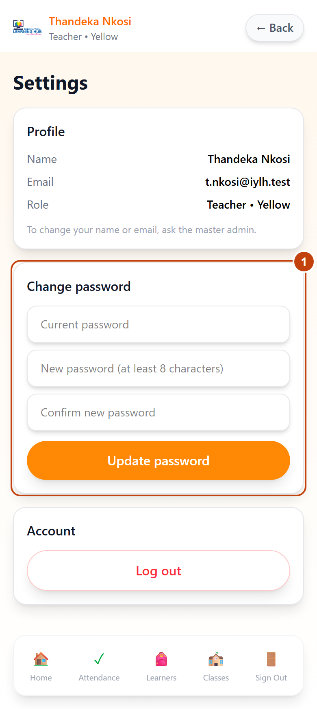
Figure 4: Settings page – Change password card
After a password reset. If the master admin gave you a temporary password, the app shows Choose a new password straight after you sign in. Type the temporary password, then your own new password twice. You can't use the app until you do.
2.5 Signing out
- Open Settings and tap Log out in the Account card, or
- Managers and admins: tap ⋮ at the top right, then Log out.
Always sign out on a shared device, such as the centre's tablet.
3. Teacher guide
Teachers take the register, sign learners out at home time and record development observations. The teacher menu has five buttons: Home, Attendance, Learners, Classes and Sign Out.
3.1 Your home page
After signing in you see your class and today's progress:
- Attendance shows Attendance not taken yet, Attendance not finished, or Complete: 12 present, 2 absent.
- Still here and Signed out list who is at the centre and who has gone home, with who collected them.
- Quick Actions take you straight to Mark Attendance, View Learners, View Classes and Sign-Out.
If you see You're not assigned to a class yet, ask the manager to assign you (section 4.4). You can still take attendance for any class.
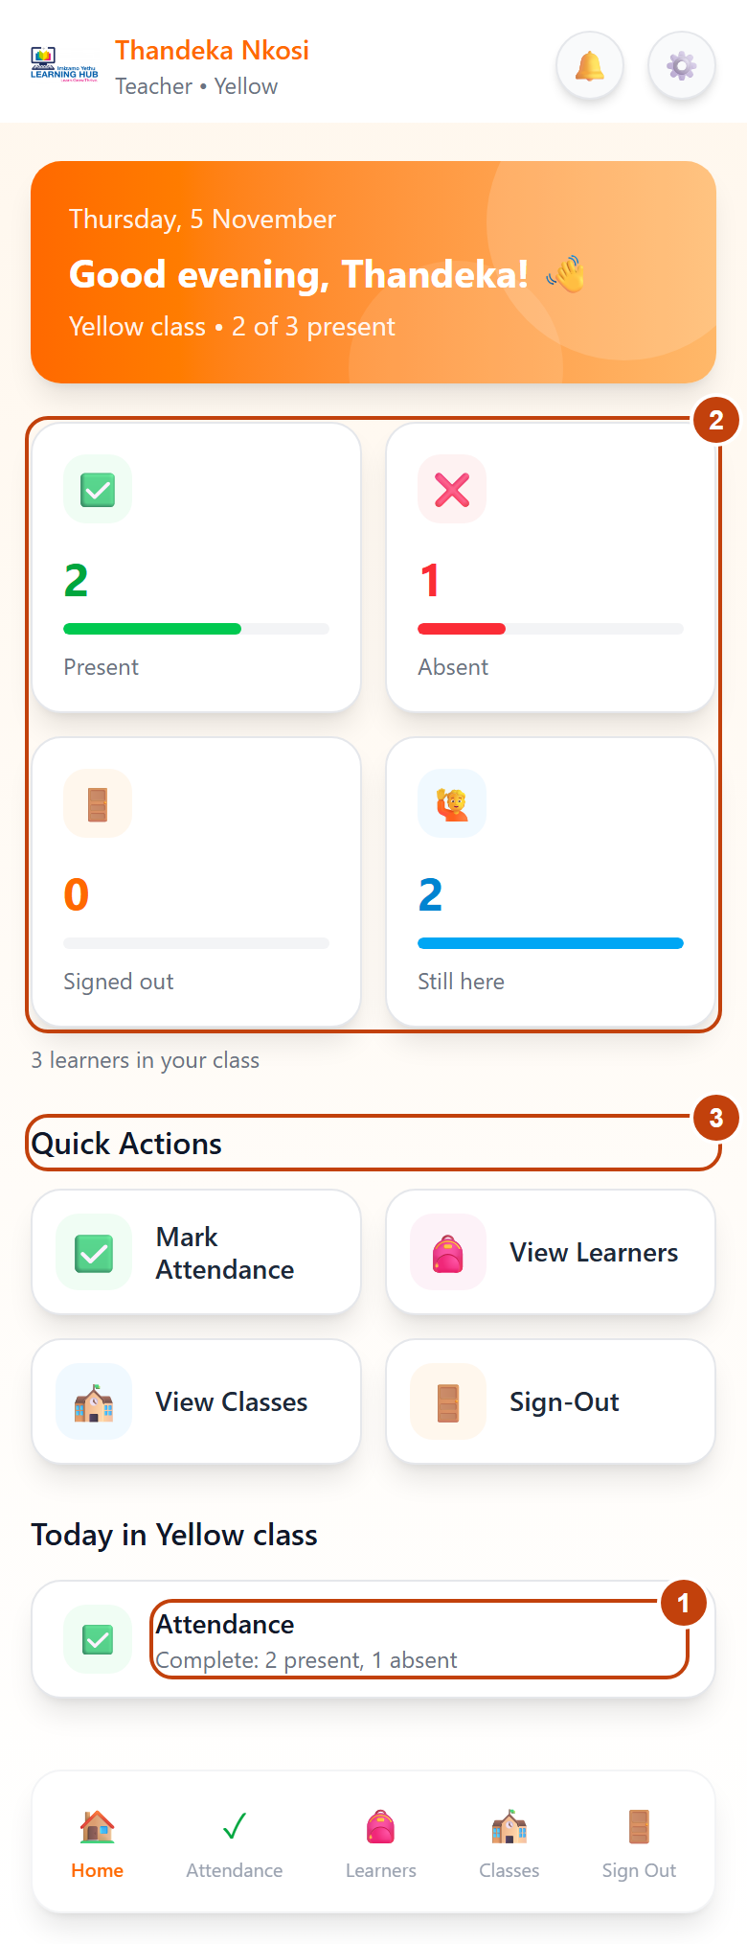
Figure 5: Teacher home page – (1) attendance status, (2) still here / signed out, (3) quick actions
3.2 Taking the daily register
- Tap Attendance. Today's date and the number of learners show under the heading.
- Tap your class pill (for example Yellow) at the top. All shows every class.
- For each learner tap Present (turns green) or Absent (turns red). Use Search learner name... to find someone quickly.
- If the whole class is in, tap All ✓ to mark everyone present, then change any absent learners. Clear undoes your unsaved marks. Both buttons only show when one class is selected, so nobody marks the whole centre by accident.
- Tap Save Attendance at the bottom. The green message Attendance saved confirms it.
The counter above the list shows, for example, 10 / 14 learners present • 2 absent.
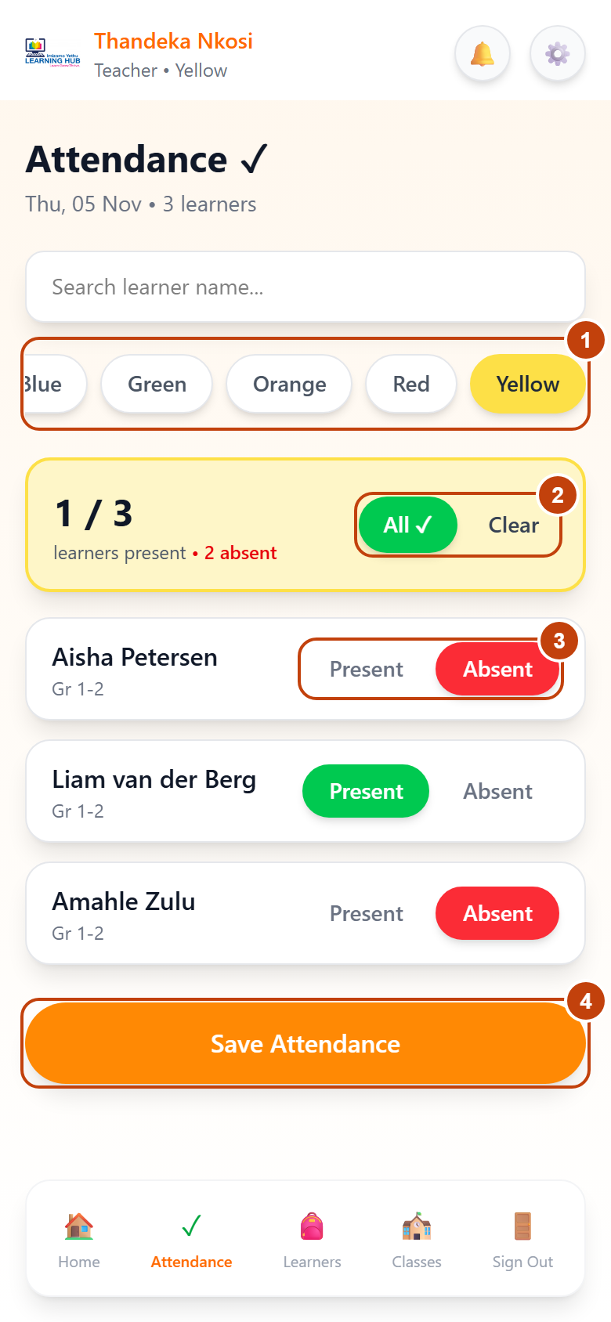
Figure 6: Attendance page – (1) class pills, (2) All ✓ and Clear, (3) Present/Absent buttons, (4) Save Attendance
Good to know:
- Correcting a mark: tap the other button and save again. Only changed learners are sent.
- Any teacher can take any class's register, for example when covering for a colleague.
- Nothing new to save means you have not changed any marks since the last save.
- If a few learners fail to save, the message says how many. Your marks stay on screen, so tap Save Attendance again.
- A learner must be marked present before they can be signed out.
3.3 Signing a learner out at home time
The app checks that the person collecting a child is on that child's authorised pickup list before the child leaves.
- Tap Sign Out. You see every learner marked present today who has not yet gone home. Use the class pills or search to find the child.
- Tap Sign Out next to the learner's name.
- Under Verify Collector, tap the person collecting from the Authorised Pickups list. Their button turns green with a tick. You can also type their name.
- If the learner is going home on their own, tap Walking Home. Allowed next to it means the parent has given permission.
- Tap Verify ✓.
- On the green Verified! screen, check the Sign-Out Summary (learner, collector, time, your name), then tap Confirm Sign-Out.
- The screen shows, for example, Aisha is signed out! Collected by Fatima Petersen at 17:15. Tap Sign Out Another Learner to continue.
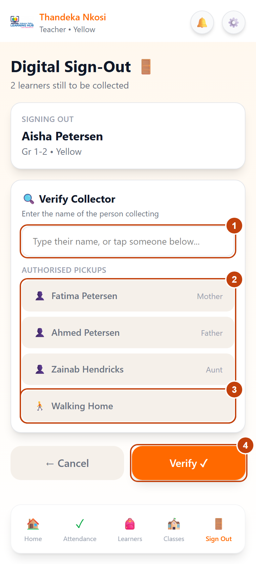
Figure 7: Verify Collector screen – (1) name box, (2) authorised pickups, (3) Walking Home, (4) Verify
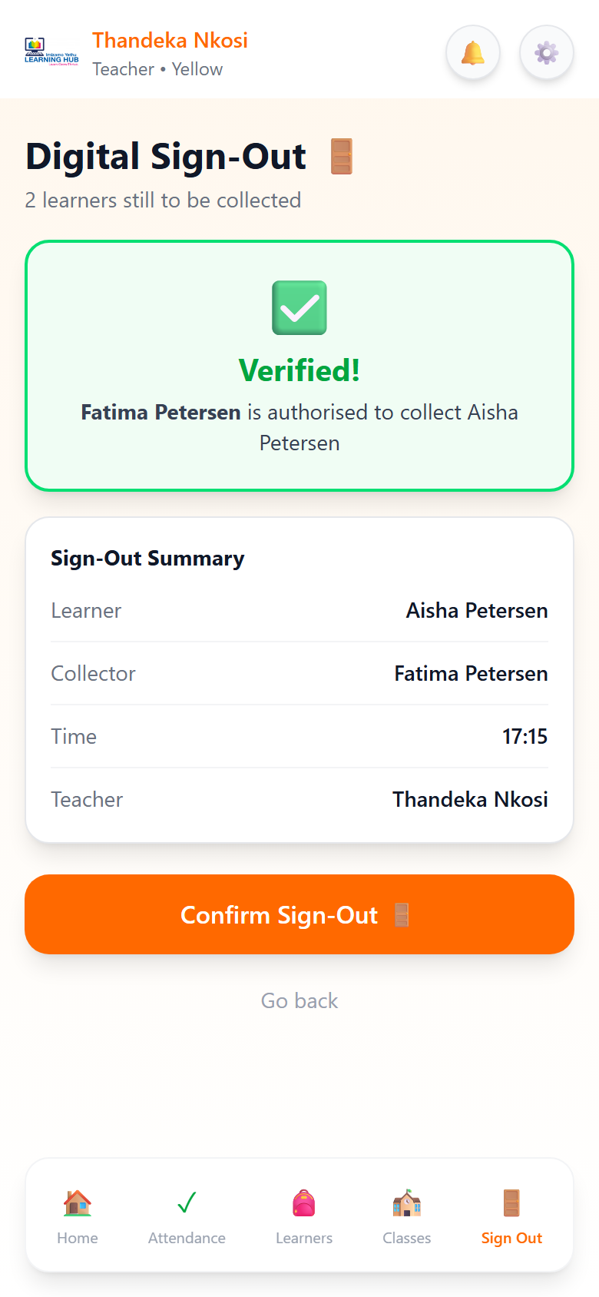
Figure 8: Verified! screen with Sign-Out Summary and Confirm Sign-Out
Learners who have gone home move to ALREADY COLLECTED TODAY with the time and collector.
When the person is not authorised. If you type a name that is not on the list, or tap Walking Home for a learner without that permission, the app shows Needs manager approval and the reason. Do not let the child leave. Tap Send to manager queue, then tell the manager in person: the manager queue is not connected yet, so nothing is sent or saved. Tap Go back to choose someone else.
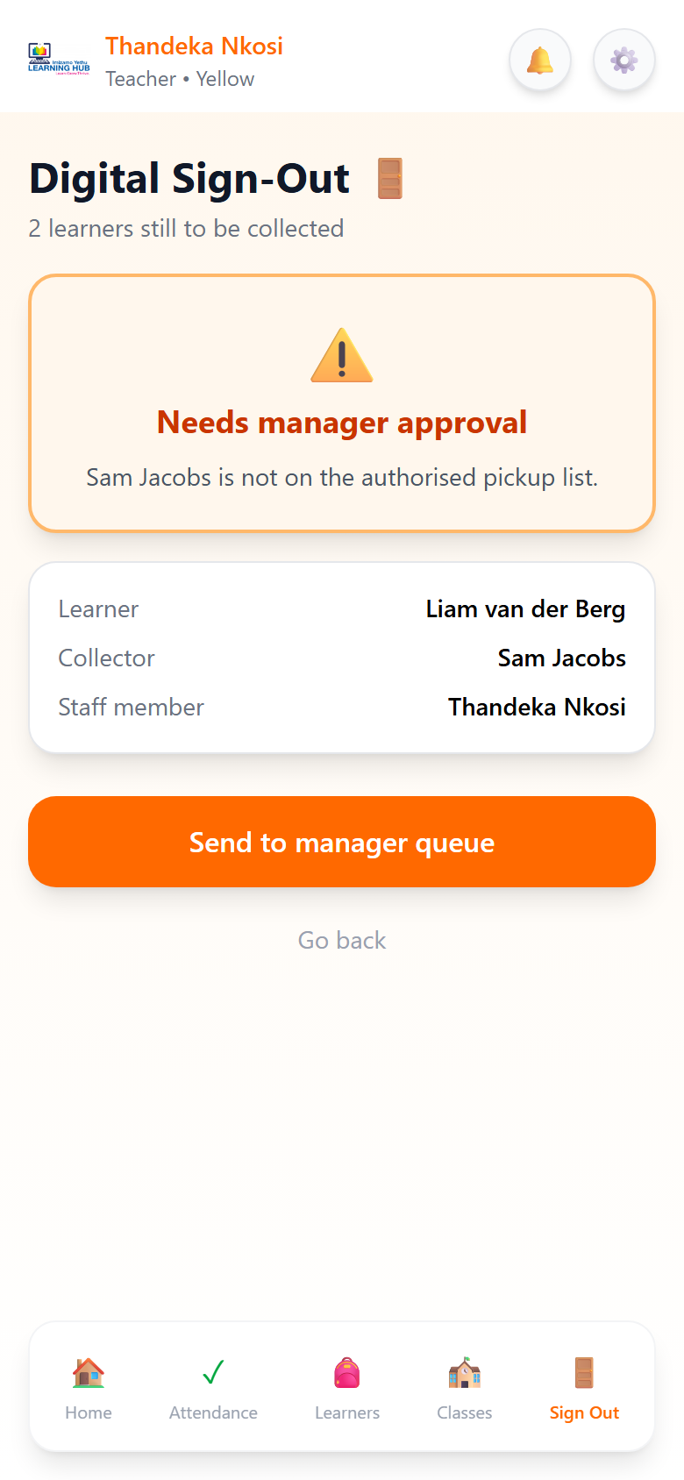
Figure 9: Needs manager approval screen
The server checks the pickup list again when you confirm. It also refuses a sign-out if the learner was not marked present today, or was already signed out.
3.4 Viewing a learner and recording observations
- Tap Learners, then tap a learner's name (you can also tap a class on the Classes page to see only its learners).
- The learner's page shows three numbers at the top: Attendance (% of the last 30 days), Age and Observations. Below are three tabs:
  - Profile: name, class, date of birth, who may collect them (with the Primary contact marked) and whether they may walk home alone.
  - Observations: all notes recorded for this learner, newest first.
  - Attendance: the most recent days, with arrival time and who collected them.
- To add an observation, open Observations and tap + Add Observation.
- Choose a category: Academic, Social, Wellbeing, Creative or Physical.
- Write what you saw in the box, then tap a rating from 1 (needs support) to 10 (excellent).
- Tap Save. The observation appears at the top of the list and parents see it on their child's page.
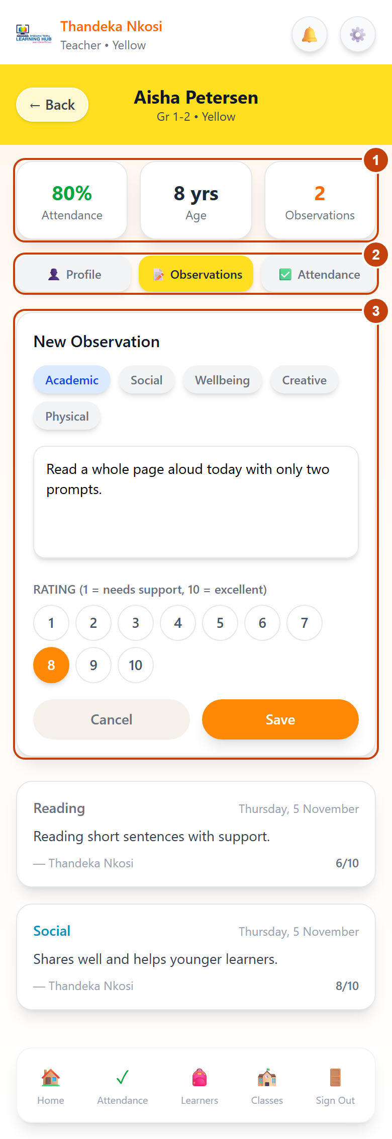
Figure 10: Learner page – (1) summary numbers, (2) tabs, (3) New Observation form with category, notes and rating
Learners that a manager has deactivated show greyed out with a 🔒 and can't be opened.
3.5 Classes and your settings
- Classes lists every class with its grade range, teacher and how many learners are present today. Tap a class to see its learners.
- Settings (⚙️) shows your name, email and role. To change your name or email, ask the master admin. You can change your password (2.4) and Log out here.
4. Manager guide
Managers run the centre: learners, classes, teachers, sign-out and reports. The manager menu has six buttons: Home, Attendance, Learners, Classes, Sign Out and Reports. The master admin sees these same pages, plus the extra tools in section 6.2.
4.1 Your dashboard
The manager home page shows today at a glance:
- Four counters: Present Today, Signed Out, Total Learners and Escalations.
- Quick Actions: Attendance, Learners, Sign-Out, Queue, Staff and Reports.
- Class Overview: how many learners are present in each class today.
- Recent Activity: today's sign-outs, with who collected each learner.
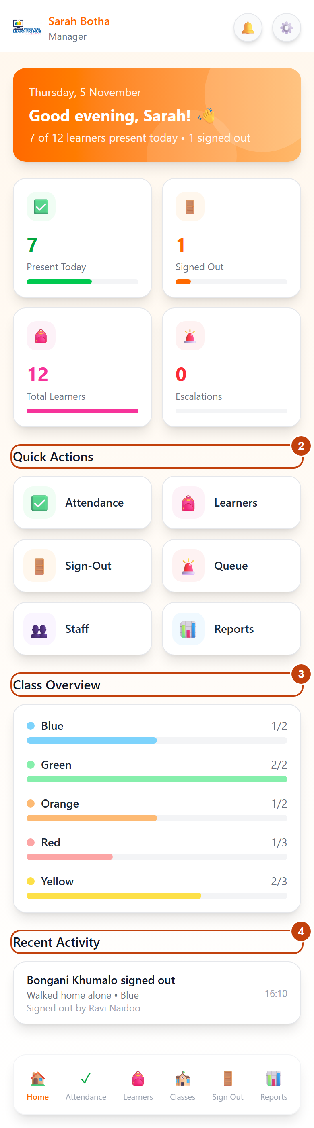
Figure 11: Manager dashboard – (1) counters, (2) quick actions, (3) class overview, (4) recent activity
4.2 Viewing attendance
Tap Attendance, then a class pill. Managers see each learner as Present, Absent or Not marked yet, with view only under the heading. Only teachers take the register.
4.3 Managing learners
Add a learner
- Tap Learners, then + Add.
- On Add New Student, type the first and last name and pick the Class. The date of birth is optional, but parents need it to register (2.3).
- Tap Add Student.
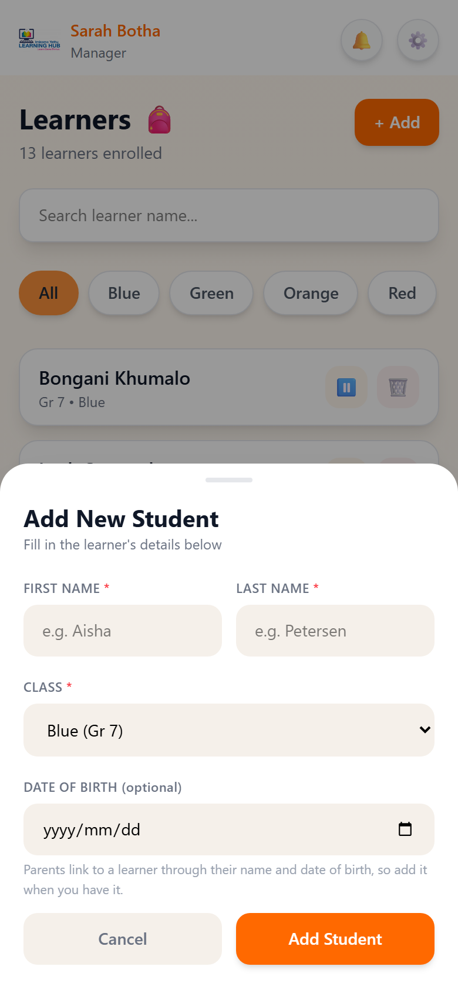
Figure 12: Add New Student form
Edit a learner or move them to another class
- Tap the learner's name, then Edit details on the Profile tab.
- Change the name, date of birth or Class, then tap Save. Learner details saved confirms it.
Deactivate, reactivate or delete
Each learner card has buttons to Deactivate, Reactivate or delete (🗑). The app asks you to confirm each one.
Action | What happens | Use it when
Deactivate | The learner stays on the teachers' list, greyed out, and can't be opened. Their history is kept | A child leaves the centre
Reactivate | Teachers can open and mark the learner again | A child returns
Delete | The learner is removed permanently. Only works if they have no attendance, observations, pickups or sign-outs | A learner was added by mistake
4.4 Managing classes
Add a class
- Tap Classes, then + Add Class.
- Type the Class Name (for example Brown), pick a GRADE RANGE (Gr R, Gr 1-2, Gr 3-4, Gr 5-6 or Gr 7) and a CLASS COLOUR.
- Tap Add Classroom. Two active classes can't share a name.
Change the grade or assign a teacher
- Tap the ✏️ button on the class card.
- On Edit Classroom, choose the GRADE RANGE and the TEACHER (or No teacher).
- Tap Save.
Remove a class
- Tap the 🗑 button on the class card.
- If learners are still in the class, choose the class to move them to, then tap Move & remove. If there is no other class, add one first.
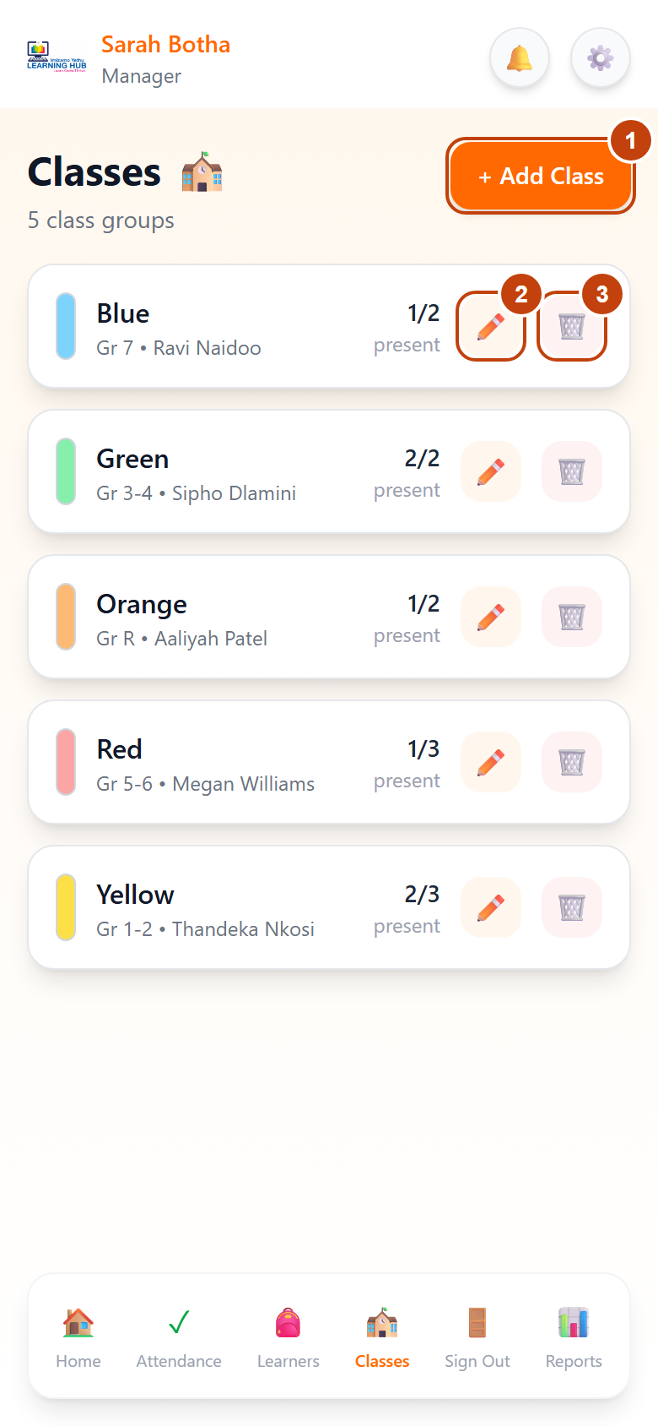
Figure 13: Classes page – (1) + Add Class, (2) ✏️ edit button, (3) 🗑 remove button
A removed class is kept in the records for reports, but is hidden from the lists.
4.5 Managing teachers (Staff)
- On the dashboard tap Staff. Staff oversight lists the teachers and managers linked to the hub, each marked Active or Suspended.
- To add a teacher, fill in Add a teacher: FULL NAME, EMAIL (they sign in with this) and a STARTING PASSWORD of at least 8 characters. Tap Add teacher and give them their email and password.
- To stop a teacher signing in, tap Suspend. It takes effect straight away, even if they are already signed in. Tap Restore to undo it.
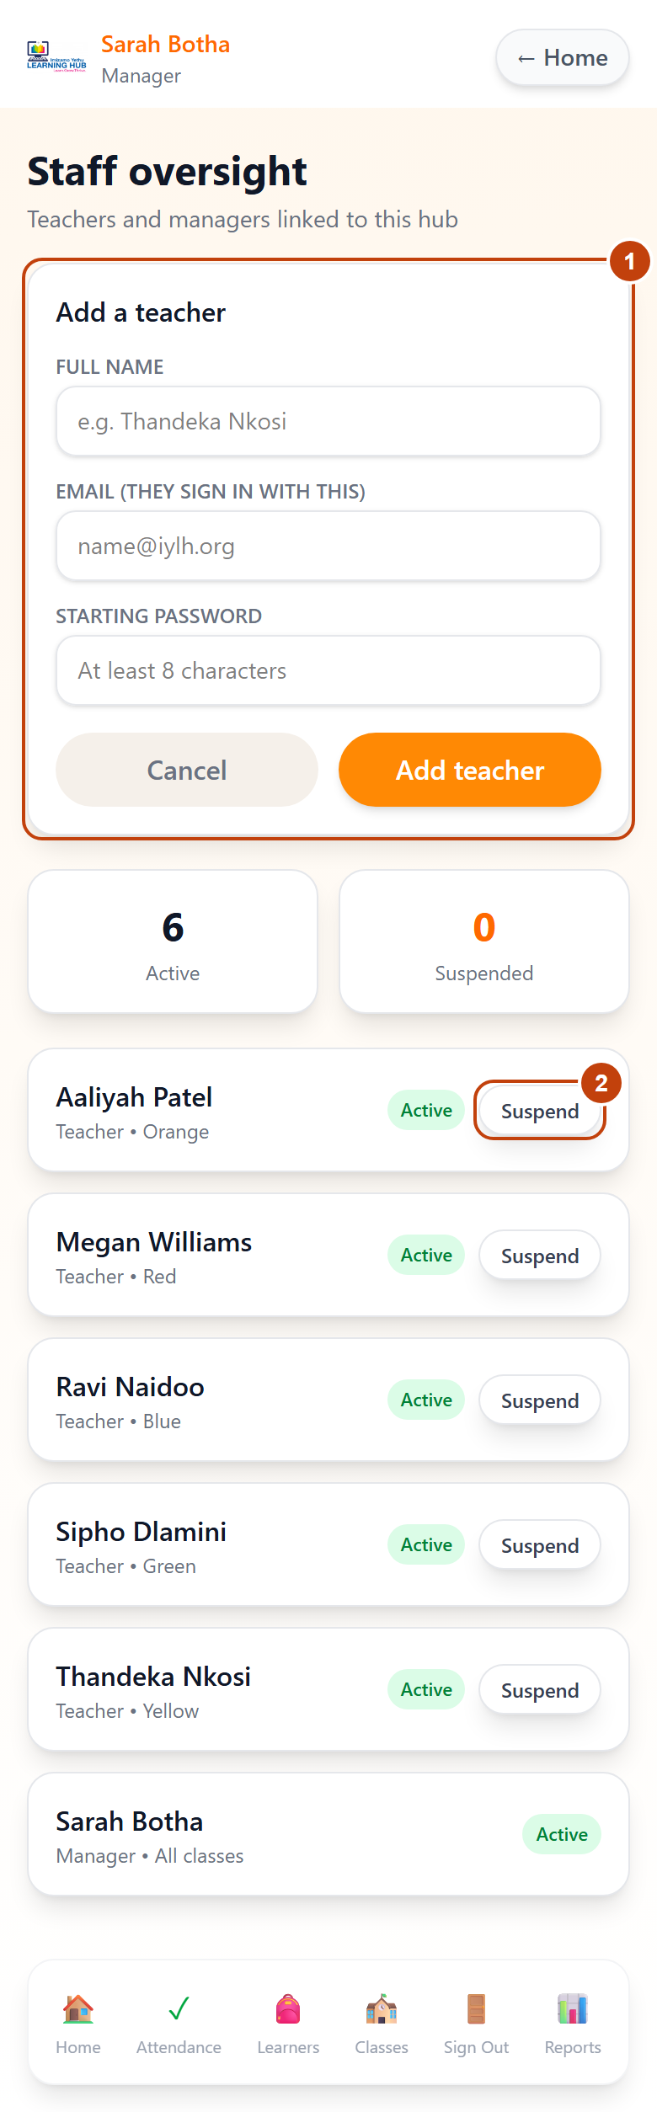
Figure 14: Staff oversight – add teacher form and Suspend/Restore buttons
4.6 Signing learners out
Managers can sign learners out exactly as teachers do (section 3.3). The summary shows Manager and your name. The Queue button on the dashboard opens the Sign-out queue, where flagged collections will be approved or dismissed. This screen currently shows sample data and is not yet connected, so handle flagged collections in person.
4.7 Reports and PDF exports
- Tap Reports. The page covers the last 90 days by default.
- Choose a tab:
  - Overview: total learners, average attendance, observations, classes, this week's daily attendance, attendance by class and observations by category.
  - Trends: the organisation's attendance trend and each class this week against last week.
  - Donor Report: key impact metrics for funders, such as learners served, attendance rate, safe collections this month and days of aftercare delivered.
  - Board Report: short points under Enrolment, Operations and Wellbeing.
- Tap 📄 Export as PDF at the bottom of the tab to download that report.
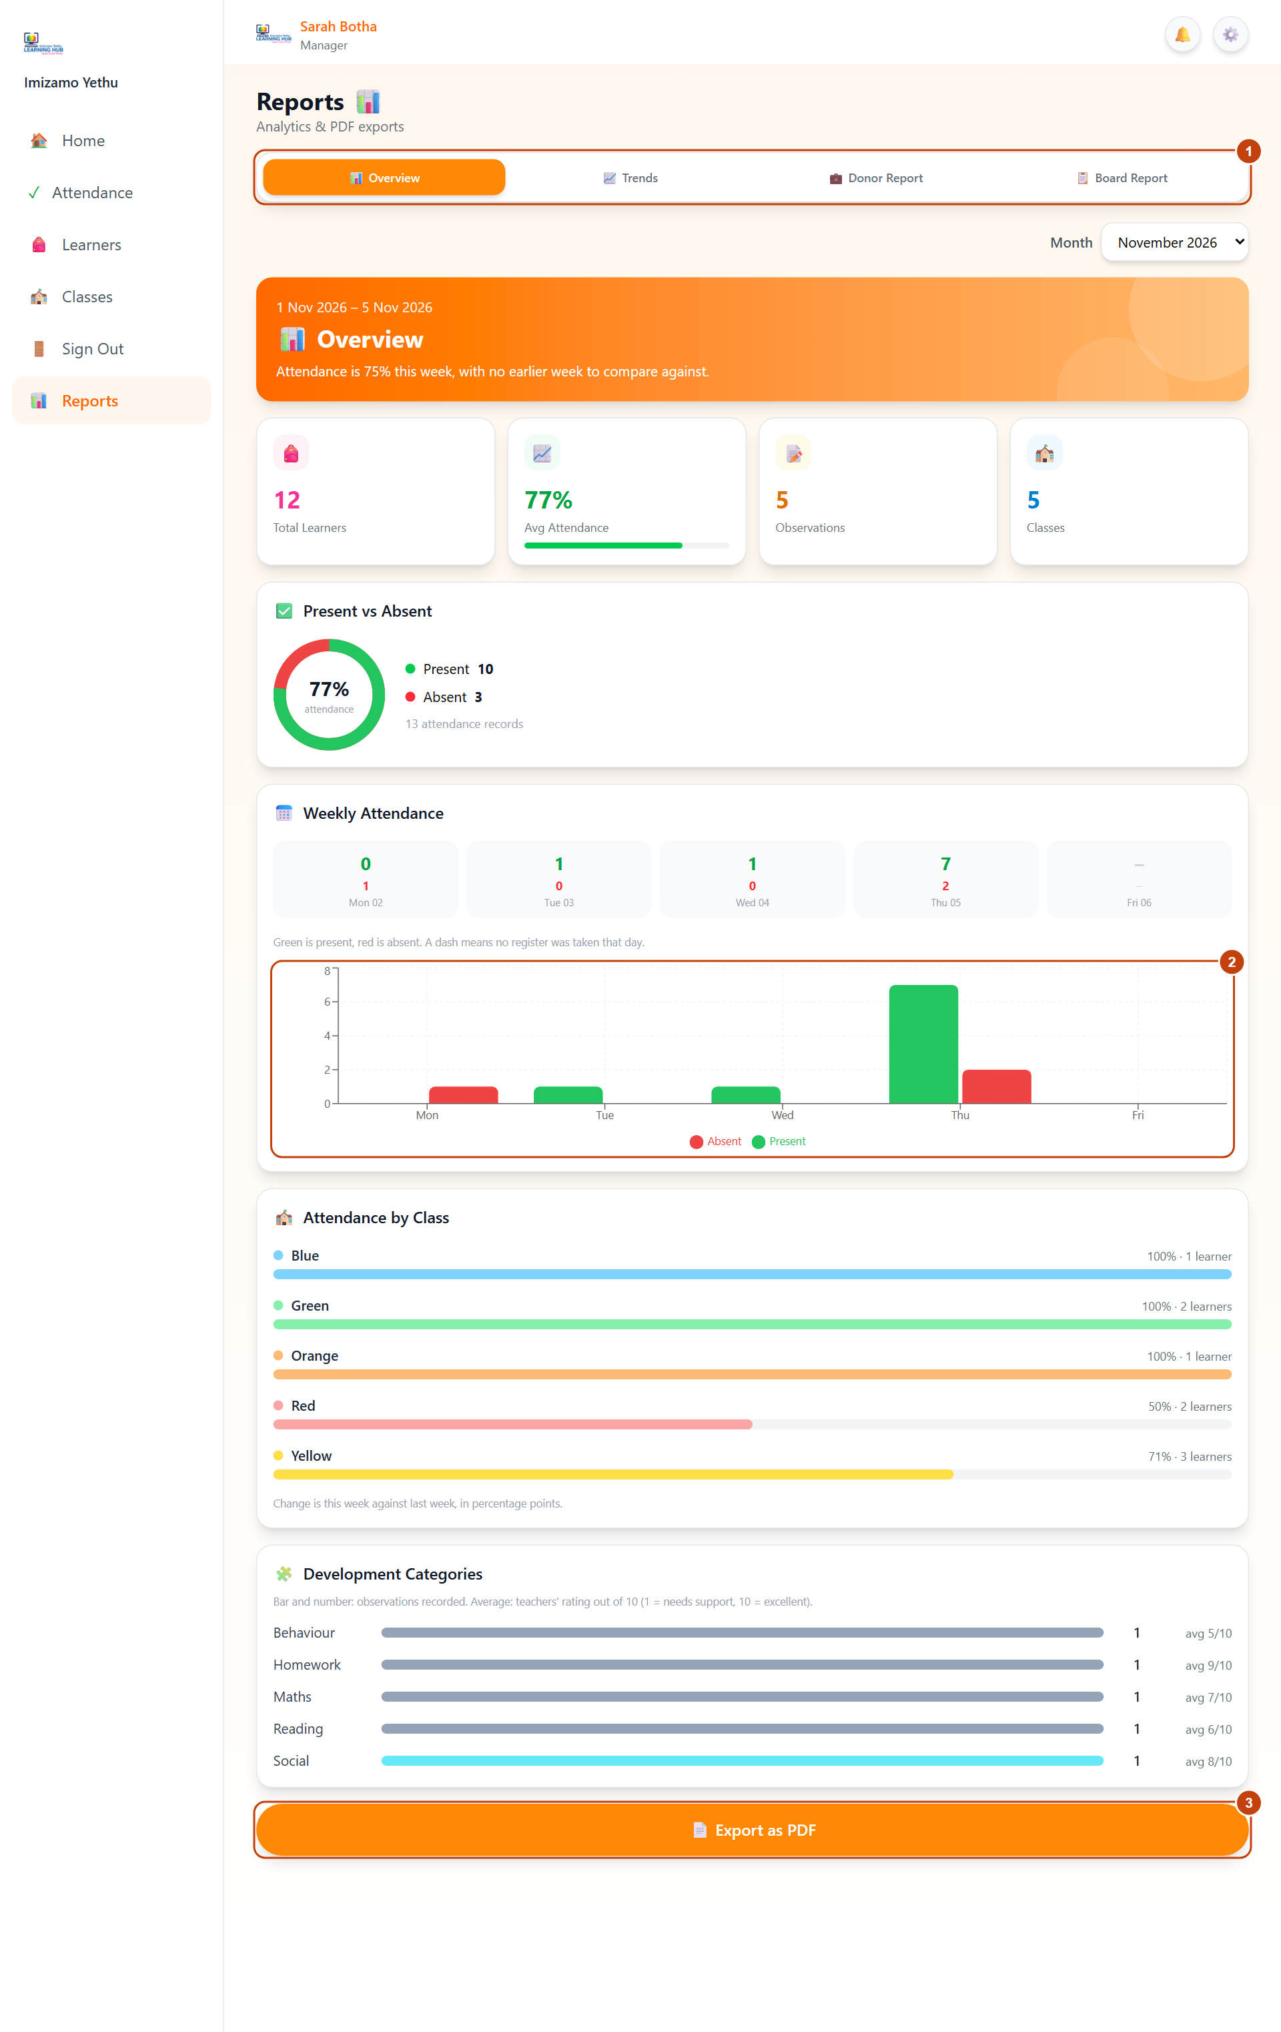
Figure 15: Reports page – (1) tabs, (2) charts, (3) Export as PDF
Reports show counts and percentages only, never individual children's names.
4.8 Settings
Tap ⋮ then Settings to see your profile, go to Manage classes, change your password or Log out.
5. Parent and guardian guide
Parents see their own children's day, attendance, teacher notes and pickup list on one page, My Child. You never see other families' information.
5.1 Your child's page
After you sign in, My Child opens. If you have more than one child at the centre, tap a child's name at the top to switch.
Part of the page | What it shows
Three counters | Attendance (% over the last 30 days), Today (Present ✓ or Not marked) and Updates (number of teacher observations)
Today | When your child arrived (Arrived at 14:05) and who collected them (Signed out by Fatima Petersen at 17:15, or Walked home alone)
Teacher Observations | The latest note from a teacher, with its category, rating out of 10 and the teacher's name. Tap View all to see every note
Authorised Pickups | Everyone who may collect your child. You are marked (you). May walk home alone shows ✓ Allowed if you gave permission
This Week | Each day in the last 7 days, present or absent, and who collected your child
Need to get in touch? | The class teacher's name and email address. Tap the email to write to them
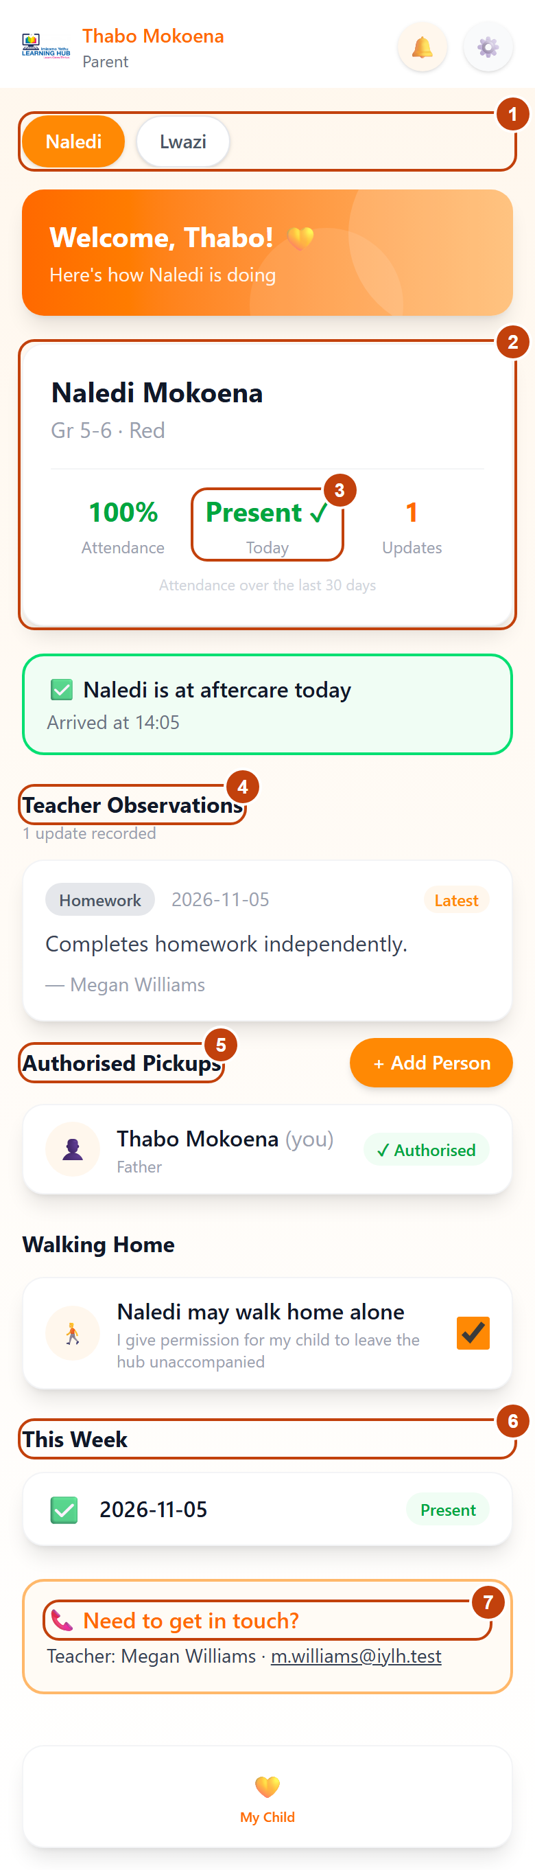
Figure 16: My Child page – (1) child switcher, (2) counters, (3) today, (4) observations, (5) authorised pickups, (6) this week, (7) teacher contact
If something looks wrong, for example your child is shown as absent, contact the teacher.
5.2 Adding someone who may collect your child
Add anyone who might fetch your child, such as a grandparent, aunt or neighbour. They don't need an account.
- Under Authorised Pickups, tap + Add Person.
- Fill in FULL NAME, RELATIONSHIP TO CHILD and CONTACT NUMBER.
- If your child may leave the centre on their own, tick I give permission for my child to leave the hub unaccompanied.
- Tap Submit Request. The person appears on the list straight away and teachers can release your child to them.
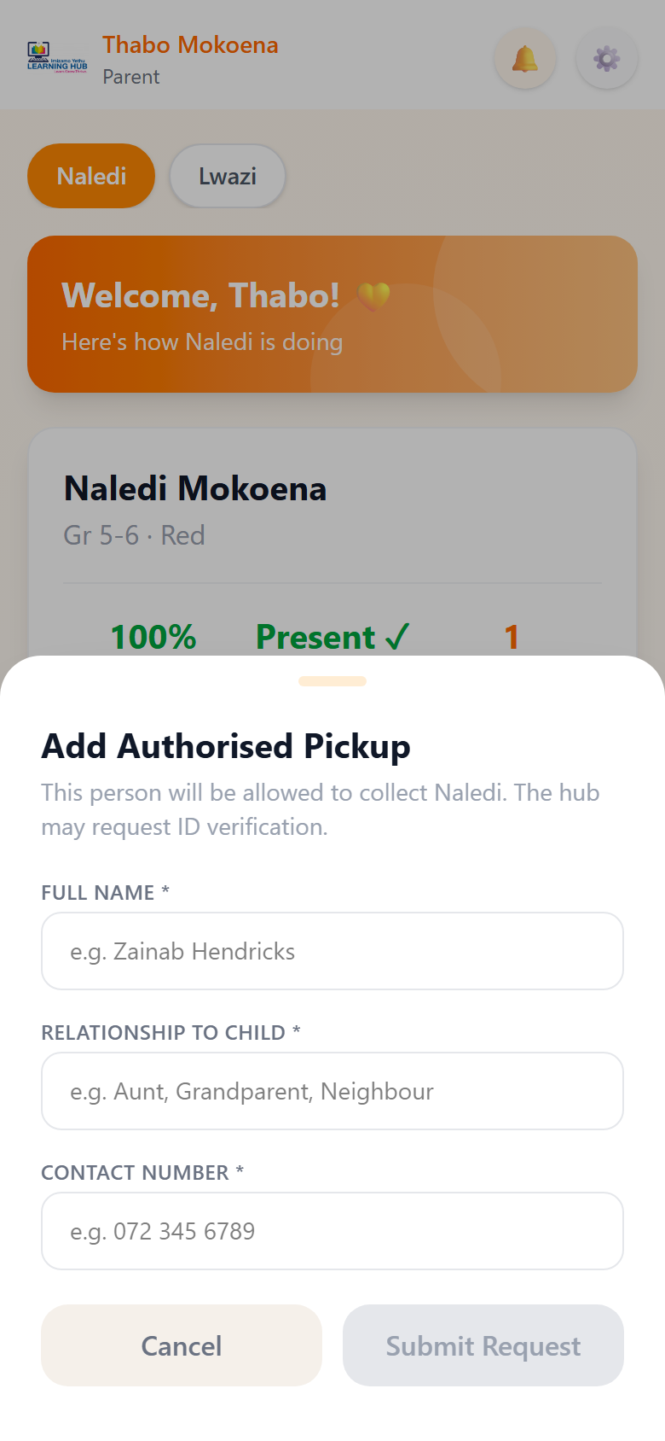
Figure 17: Add Authorised Pickup form
The teacher must see the person's name on this list before your child can leave with them. Anyone not on the list is held back until the manager approves. To remove someone from the list, contact the centre.
5.3 Settings
Tap ⚙️ at the top right to see your name, your child and your phone number, change your password (2.4) or Log out. Tap ← Back to return to My Child.
6. Admin guide
There are two kinds of admin. Both pick the Admin card when signing in.
 | Standard admin | Master admin
Lands on | Admin home | Manager dashboard
Sees | Totals and reports only, never individual learners | Everything a manager sees
Can do | View today's numbers and reports, export PDFs | Everything a manager can, plus manage staff accounts and reset passwords
6.1 Standard admin
The admin menu has three buttons: Home, Reports and Settings.
- Home shows Present Today, Signed Out and Total Learners, plus a Class Overview with the number present in each class. Only counts are shown, never names (POPIA).
- Reports has the same four tabs as the manager's (section 4.7): Overview, Trends, Donor Report and Board Report. Tap 📄 Export as PDF to download one.
- Settings shows your profile and lets you change your password or Log out.
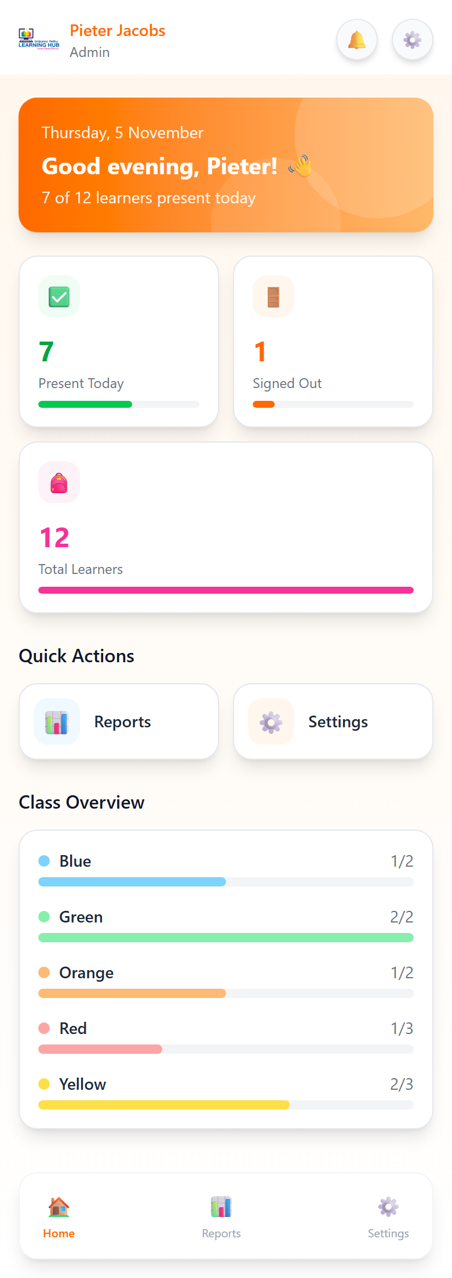
Figure 18: Admin home page
6.2 Master admin: managing staff accounts
The master admin uses all the manager pages in section 4. On the dashboard, tap Staff to reach the extra tools.
Add a manager or standard admin
- Scroll to Managers & admins at the bottom of the Staff page.
- Under Add a manager or admin, choose the ACCOUNT TYPE: Manager (runs the hub) or Standard admin (sees reports and totals only).
- Fill in FULL NAME, EMAIL (they sign in with this) and a STARTING PASSWORD of at least 8 characters.
- Tap Add manager or Add standard admin, and give the person their email and password.
Teachers are added in the Add a teacher form above it (section 4.5).
Edit a staff member's name or email
- Tap Edit next to the teacher, manager or admin.
- Change the FULL NAME or EMAIL, then tap Save changes.
You can edit your own account, but not another master admin's.
Reset a forgotten password
- Tap Reset password next to the person.
- Type a temporary password twice (at least 8 characters) and tap Reset password.
- Give them the temporary password. They are signed out everywhere and must choose their own password the next time they sign in (section 2.4), so you never know their final password.
To change your own password, use Settings instead.
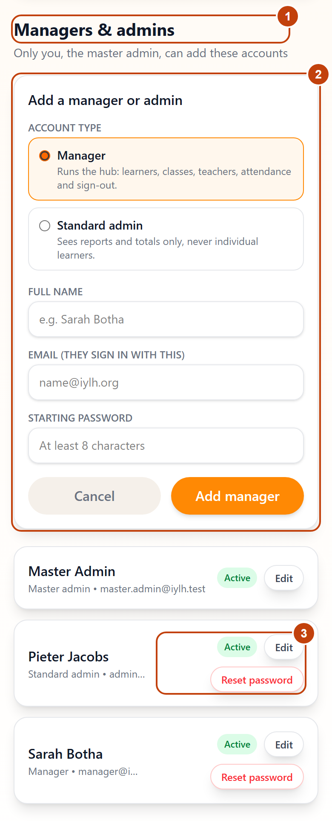
Figure 19: Staff page – (1) Managers & admins list, (2) Add a manager or admin form, (3) Edit and Reset password buttons
7. Troubleshooting and FAQ
7.1 Messages you might see
Message | What it means | What to do
Invalid email or password | The email or password is wrong | Check for typing mistakes and Caps Lock. Staff who forgot their password: ask the master admin for a reset (6.2)
Wrong account type for the role selected | The role card doesn't match your account | Tap the correct card (Teacher, Manager, Admin or Parent/Guardian) and sign in again
This account has been deactivated | A manager or the master admin has suspended your account | Contact the centre manager
Too many requests, please try again later. | Too many wrong passwords in 15 minutes (a protection against password guessing) | Wait 15 minutes, then try again carefully
We couldn't find a learner with that name and date of birth | Registration couldn't match your child | Check the spelling and date of birth, or ask the centre how your child is listed
An account with this email already exists | Someone has already registered with this email | Sign in instead, or use another email
Nothing new to save | No attendance marks have changed since the last save | Mark learners Present or Absent first
Attendance has already been recorded for this learner today | Another teacher saved this learner already | Refresh the page; correct the mark if needed
This learner has not been marked present today, so they cannot be signed out | The register hasn't been taken for this child | Mark the child present on Attendance, then sign them out
This learner was already signed out today at 17:15 | The child has already left | Check ALREADY COLLECTED TODAY
Needs manager approval | The collector isn't on the pickup list, or the child may not walk home alone | Keep the child at the centre and call the manager
Please choose a new password before continuing | Your password was reset | Enter the temporary password and choose your own (2.4)
7.2 Common questions
I was signed out unexpectedly. Sessions last 8 hours. Changing your password, or a reset by the master admin, also signs you out on other devices. Sign in again.
The page is blank or stuck on Loading.... Check your internet connection and refresh the page. If it continues, try another browser or clear the browser's cache.
A learner is missing from my attendance list. Check the right class pill is selected, or tap All. If the learner is missing everywhere, ask the manager to add or reactivate them (4.3).
Can I take attendance for a class that isn't mine? Yes. Any teacher can take any class's register.
A parent's helper isn't on the pickup list. The parent adds them from My Child → + Add Person (5.2). Until then, the child stays until the manager approves.
How do I change my email address? Staff: ask the master admin. Parents: contact the centre.
Can I use the app on my phone? Yes. Every page adapts to phone, tablet and computer screens.
Is my child's information safe? Passwords are stored scrambled (hashed), never as plain text, sessions use a secure cookie, and every request is checked against your role. Parents only see their own children, and admin reports never show names.
8. Support and glossary
8.1 Who to contact
Problem | Contact
Forgotten staff password, new staff account, change of staff name or email | The master admin
Missing learner, wrong class, teacher not assigned, account suspended | The centre manager
Parent: wrong child details, pickup person to remove, registration not matching | The centre manager or your child's teacher (email shown on My Child)
The app is down or showing errors for everyone | The centre manager, who reports it to NovaTech Solutions
8.2 Glossary
Term | Meaning
Authorised pickup | A person a parent has added who may collect their child
Primary contact | The parent or guardian who registered and is linked to the child first
Walking home | A child leaving on their own; only allowed with the parent's permission
Observation | A teacher's note on a child's development, with a category and a 1–10 rating
Deactivate / Suspend | Stop a learner or person being used, while keeping their history
Master admin | The admin who can do everything a manager can, plus manage staff accounts
Standard admin | An admin who sees reports and totals only
POPIA | South Africa's Protection of Personal Information Act, which the app follows by showing each person only what their role needs

